Scenario 1: Manufacturing Quality Inspection
An automated quality inspection system captures images of metal components. Electrical interference introduces repetitive horizontal stripes across the images, making defect detection unreliable.
(a) Interpret the scenario and identify the type of noise present.
(b) Explain how this degradation affects inspection accuracy.
(c) Recommend an appropriate enhancement technique to remove the interference.
(d) Justify why your selected approach is more suitable than spatial-domain methods.
(e) Explain your answer in a logical sequence.

Introduction
In modern manufacturing industries, automated quality inspection systems use digital image processing to identify defects such as cracks, scratches, dents, and surface imperfections in metal components. High-quality images are essential because even a small defect can reduce product reliability and safety. However, electrical interference during image acquisition may introduce repetitive horizontal stripe patterns into the captured images. These unwanted patterns make it difficult for the inspection system to distinguish actual defects from noise. Therefore, an effective image enhancement technique is required to remove the interference while preserving the original details of the metal component.

(a) Interpretation of the Scenario and Identification of Noise
The given scenario describes an automated inspection system where captured images contain repetitive horizontal stripes caused by electrical interference. This type of degradation is known as Periodic Noise.
Periodic noise differs from random noise because it follows a regular repeating pattern. It is usually generated by electrical equipment, power supply fluctuations, electromagnetic interference, or sensor malfunction during image acquisition.
Characteristics of periodic noise include:
- Repeating horizontal or vertical stripe patterns.
- Appears at regular intervals.
- Easily visible in the frequency domain.
- Difficult to remove using ordinary spatial filters.
Thus, the image is degraded due to periodic noise introduced by electrical interference.
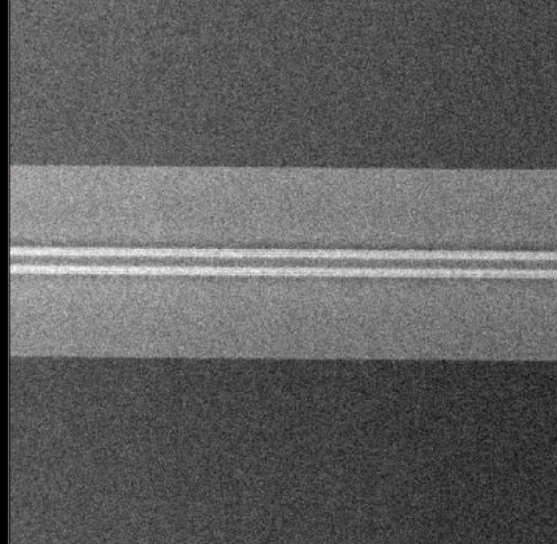
(b) Effect of the Noise on Inspection Accuracy
Periodic noise significantly reduces the performance of the quality inspection system.
Its effects include:
- Hides small defects such as scratches and cracks.
- Produces false edges that may be interpreted as defects.
- Reduces image clarity and contrast.
- Decreases segmentation accuracy.
- Increases false positive and false negative detections.
- Lowers overall inspection reliability.
For example, a fine crack on the metal surface may overlap with the horizontal stripes, making the crack invisible to the inspection software. Similarly, the stripe itself may be incorrectly classified as a defect.
As a result, defective products may pass inspection while good products may be rejected unnecessarily.

(c) Recommended Enhancement Technique
The most suitable enhancement method is:
Fourier Transform followed by Notch Filtering
Step 1: Fourier Transform (FFT)
The image is converted from the spatial domain into the frequency domain using the Fast Fourier Transform (FFT).
In the frequency domain:
- Low frequencies represent smooth image regions.
- High frequencies represent edges and fine details.
- Periodic noise appears as bright symmetric peaks.
This makes the unwanted frequencies easy to identify.
Step 2: Notch Filter
A Notch Filter removes only the specific frequencies corresponding to the periodic noise.
The filter blocks the unwanted peaks while preserving the remaining useful frequency components.
After filtering, the image is transformed back into the spatial domain using the Inverse Fourier Transform (IFFT).
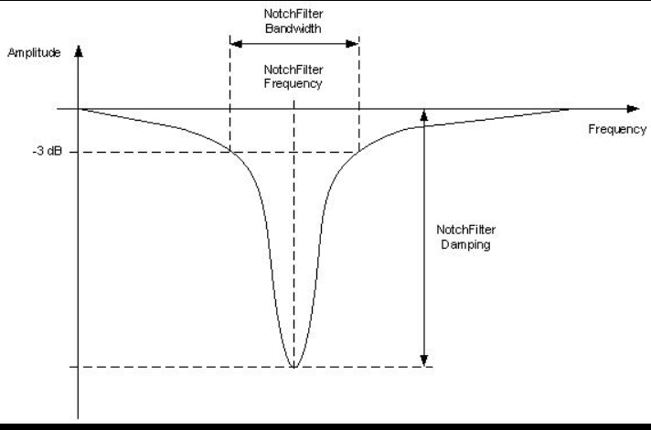
(d) Justification for Choosing Frequency Domain Method
The frequency-domain approach is superior because periodic noise is localized at specific frequency locations.
Advantages include:
- Removes only unwanted frequencies.
- Preserves image details and edges.
- Prevents blurring.
- Improves defect visibility.
- Produces high inspection accuracy.
Spatial-domain filters such as averaging or median filters process every pixel equally. They cannot distinguish between noise and actual image details.
Therefore, spatial filters either:
- fail to remove periodic noise completely, or
- blur important defect information.
Notch filtering removes only the interference frequencies without affecting the remaining image.
Hence it is much more effective.
(e) Logical Sequence of Image Enhancement
The complete process is:
- Capture image of metal component.
- Observe repetitive horizontal stripe noise.
- Apply Fourier Transform.
- Identify bright frequency peaks caused by periodic noise.
- Design and apply Notch Filter.
- Remove unwanted frequency components.
- Apply Inverse Fourier Transform.
- Obtain enhanced image.
- Perform defect detection.
- Improve manufacturing quality inspection.
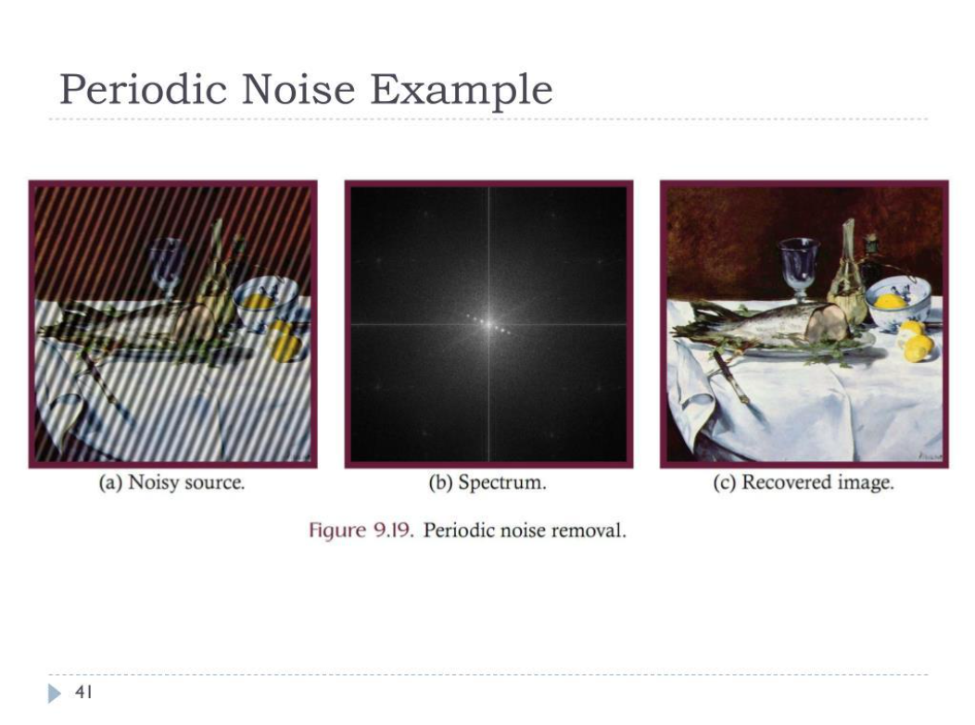
Conclusion
The manufacturing inspection system suffers from periodic noise caused by electrical interference. The most appropriate solution is Fourier Transform with Notch Filtering because it removes only the unwanted periodic frequencies while preserving image details. Compared with spatial filtering, frequency-domain enhancement provides higher inspection accuracy, better defect visibility, and improved reliability of automated quality inspection systems.

Scenario 2: Autonomous Vehicle Navigation
A self-driving car captures road images during heavy rain. Although noise is present, the lane markings and road edges must remain sharp for safe navigation.
- Interpret the scenario and explain the challenge involved.
- Identify the importance of preserving edges while removing noise.
- Recommend a suitable filtering technique.
- Justify why your selected filter preserves important image details.
- Present your explanation clearly and systematically.

Introduction
Autonomous vehicles rely on cameras to capture road images for lane detection, obstacle recognition, traffic sign identification, and navigation. During heavy rain, water droplets and environmental disturbances introduce noise into the captured images. Although the noise must be removed, the lane markings and road boundaries should remain sharp because they are critical for safe driving.
Therefore, an edge-preserving filtering technique is required.
(a) Interpretation of the Scenario
The scenario describes a self-driving car operating during heavy rainfall.
Rain introduces:
- sensor noise,
- water droplet interference,
- reduced visibility,
- low contrast.
The challenge is to remove the noise without blurring important road features.
Unlike ordinary photographs, autonomous vehicles cannot tolerate blurred lane markings because navigation decisions depend on precise edge information.

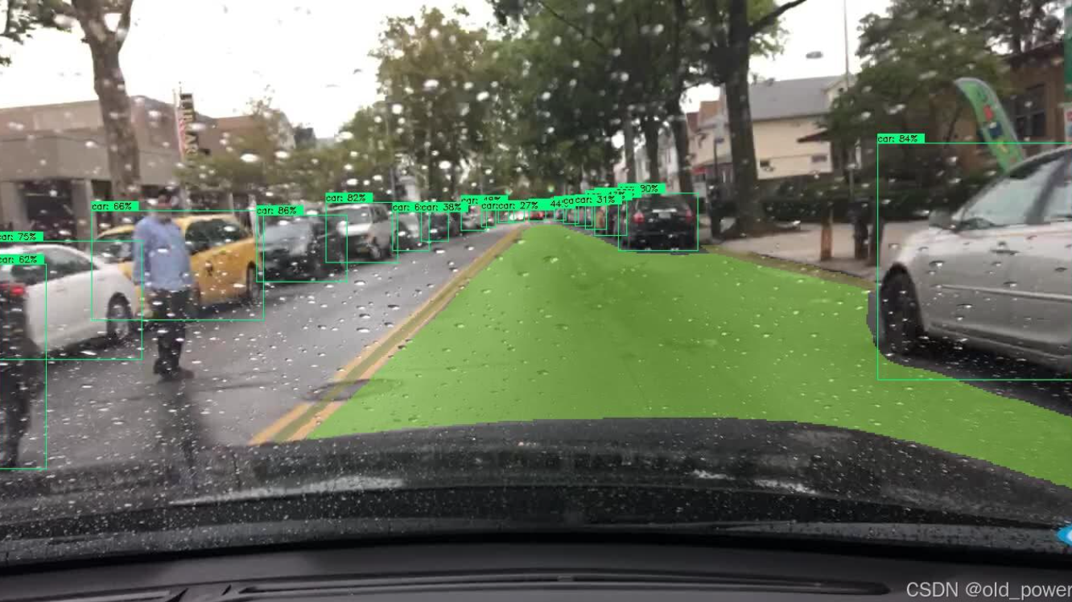

(b) Importance of Preserving Edges
Edges represent boundaries between different objects.
Examples include:
- lane markings,
- road boundaries,
- sidewalks,
- vehicles,
- pedestrians,
- traffic signs.
If edges become blurred:
- lane detection becomes inaccurate,
- obstacle recognition fails,
- vehicle positioning becomes incorrect,
- accident risk increases.
Therefore, preserving edges is essential for safe autonomous driving.
(c) Recommended Filtering Technique
The most suitable method is the:
Bilateral Filter
The Bilateral Filter performs smoothing while preserving edges.
Unlike ordinary filters, it considers two factors simultaneously:
1. Spatial Distance
Nearby pixels influence each other more than distant pixels.
2. Intensity Difference
Pixels with similar brightness are averaged together.
Pixels with very different intensity values (usually edges) are not mixed.
Thus,
- noise is removed,
- edges remain sharp.
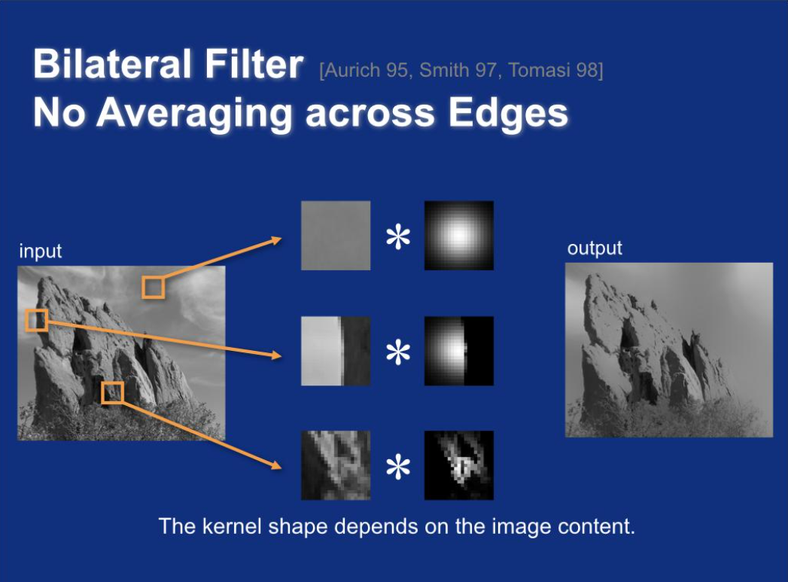

(d) Justification for Selecting Bilateral Filter
The Bilateral Filter is preferred because it preserves important image structures while removing unwanted noise.
Advantages include:
- removes rain noise,
- preserves lane markings,
- maintains road boundaries,
- improves edge detection,
- reduces false navigation decisions,
- enhances computer vision accuracy.
Comparison with other filters:
Mean Filter
- Removes noise.
- Causes heavy blurring.
Gaussian Filter
- Smooths image.
- Blurs edges.
Median Filter
- Effective for salt-and-pepper noise.
- Less effective for rain noise.
Bilateral Filter
- Removes noise.
- Preserves edges.
- Maintains important road details.
Therefore, Bilateral Filtering is the best choice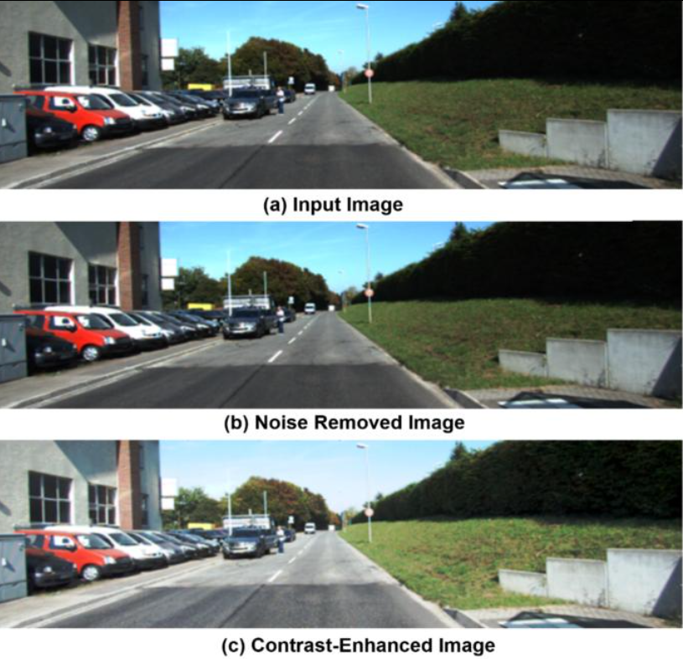
(e) Logical Processing Sequence
The enhancement process is:
- Camera captures road image.
- Heavy rain introduces noise.
- Apply Bilateral Filter.
- Remove noise while preserving edges.
- Detect lane markings.
- Detect road boundaries.
- Identify vehicles and pedestrians.
- Navigation algorithm calculates safe driving path.
- Vehicle makes accurate steering decisions.
- Safe autonomous navigation is achieved.
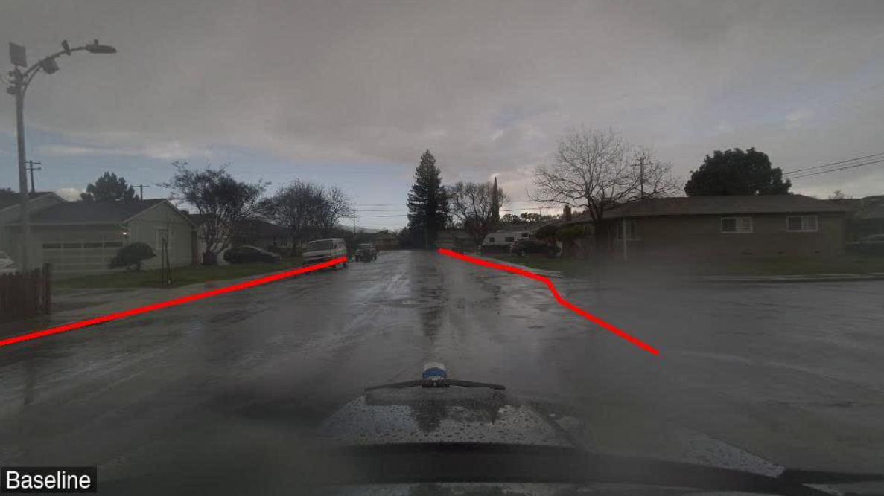

Conclusion
Heavy rain introduces unwanted noise into road images used by autonomous vehicles. Since lane markings and road boundaries are essential for navigation, edge preservation is extremely important. The Bilateral Filter effectively removes noise while maintaining sharp edges, making it the most suitable image enhancement technique for autonomous vehicle navigation. It improves lane detection, obstacle recognition, navigation accuracy, and overall driving safety.

